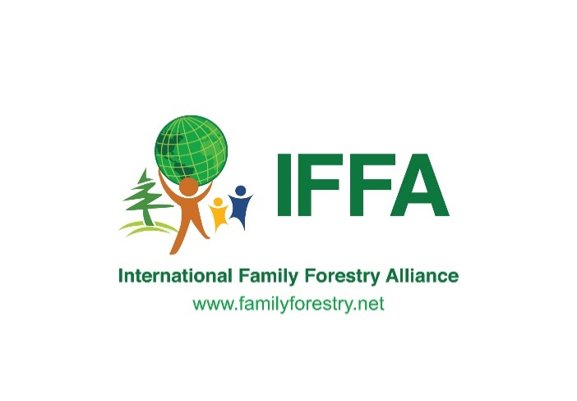

[**www.familyforestryalliance.org**](http://www.familyforestryalliance.org)

**IFFA Members**

|  |  |  |  |  |
| --- | --- | --- | --- | --- |
|  | **Member** | **Country** | **Focal Person** | **Link to Website** |
| 1 | Danish Forest Association | Denmark | Tanja Olsen | [**www.skovforeningen.dk**](http://www.skovforeningen.dk) |
| 2 | Fed. of Swedish Family Forest Owners | Sweden | **Mia Crawford- Board member** | [**https://www.lrf.se/**](https://www.lrf.se/) |
| 3 | Tanzania Tree Growers Association | Tanzania | Kastory Matembele Timbula | [**https://www.ttgau.or.tz/**](https://www.ttgau.or.tz/) |
| 4 | Latvian Forest Owners' Association | Latvia | Arnis Muiznieks | [**https://mezaipasnieki.lv/en**](https://mezaipasnieki.lv/en) |
| 5 |  | Lithuania | Jaksto G | [**https://am.lrv.lt/lt/**](https://am.lrv.lt/lt/) |
| 6 | Bavarian Forest Owner Association | Germany | **Lorenz Freiherr Klein von Wisenberg- Board Member** | [**www.waldeigentuemer.de**](http://www.waldeigentuemer.de) |
| 7 | Farm Forestry Smallholder Producers Association of Kenya | Kenya  IFFA Secretariat | **Francis Nderitu- Board member**  Edwin Kamau | [**www.ffspak.org**](http://www.ffspak.org) |
| 8 | Fédération des Forestiers Privés de France | France | **Jean Pierre Piganiol- Board Member**  **(**Luc Bouvarel) | [**https://www.fransylva.fr/**](https://www.fransylva.fr/) |
| 9 |  | Spain | Fernando Molina, Patricia Gomez | [**fernando.molina@selvicultor.es**](mailto:fernando.molina@selvicultor.es)[**patricia.gomez@selvicultor.es**](mailto:patricia.gomez@selvicultor.es) |
| 10 | Fédération des producteurs forestiers du Québec | Canada | **Vincent Miville- Board Member** | [**https://www.foretprivee.ca/**](https://www.foretprivee.ca/) |
| 11 | Association of Family Forest Owner's Nepal | Nepal | **Jog Raj Giri- Board member** | [**https://familyforestnepal.org/**](https://familyforestnepal.org/) |
| 12 | American Forest Landowner Association | USA | Scott Jones | [**https://forestlandowners.com/**](https://forestlandowners.com/) |
| 13 |  | Australia | Australian forest owners | [**national.office@afg.asn.au**](mailto:national.office@afg.asn.au) |
| 14 | Norwegian Forest Owners | Norway | Ellen Alfsen | [**https://skog.no/**](https://skog.no/) |
| 15 | The Central Union of Agricultural Producers and Forest Owners (MTK) | Finland | **Maria Pohjala- Board member** | [**https://www.mtk.fi/**](https://www.mtk.fi/) |
| 16 | Estonian Private Forest Union | Estonia | Ants Erik, Liina Laineveer | [**https://www.cepf-eu.org/page/estonia**](https://www.cepf-eu.org/page/estonia) |
| 17 | Privatbësch | Luxembourg | **Hubert De Schorlemer- President** | [**https://www.cepf-eu.org/page/luxembourg**](https://www.cepf-eu.org/page/luxembourg) |
| 18 | The Association of Austrian Land and Forest Owners | Austria | **Felix Montecuccoli-Board Member** | [**https://www.cepf-eu.org/page/austria**](https://www.cepf-eu.org/page/austria) |
| 19 | The Forest Owners Association of Slovenia | Slovenia | Marjan Hren | [**www.slovenski-gozdovi.org**](http://www.slovenski-gozdovi.org) |
| 20 |  | Switzerland | Urban Brusch  Manuela Kaiser | [**urban.brusch@waldschweiz.ch**](mailto:urban.brusch@waldschweiz.ch)  [**manuela.kaiser@waldschweiz.ch**](mailto:manuela.kaiser@waldschweiz.ch) |
| 21 | Programme for the Endorsement of Forest certification | PEFC international | Gill Parker | [**https://www.pefc.org/**](https://www.pefc.org/) |
| 22 | Confederation of European Forest Owners | CEPF | Dajana Kojic | [**www.cepf-eu.org**](http://www.cepf-eu.org) |
| 23 | Unión de Selvicultores del Sur de Europa | USSE |  | [**usse@usse-eu.org**](mailto:usse@usse-eu.org) |